# LETTER OF TRANSMITTAL

[DATE]

To

Dr. Rajesh Palit

Chairman,

Department of Electrical and Computer Engineering

North South University, Dhaka

Subject: **Submission of CSE498R Directed Research Project Report on “Ocular Disease Detection with Optimized Lightweight Deep Learning Techniques ”**

Dear Sir,

With due respect, we would like to submit my **EEE498R Directed Research Report** on **“Ocular Disease Detection with Optimized Lightweight Deep Learning Techniques”** for the completion of our CSE498R as required by Department of Electrical and Computer Engineering, North South University. The report describes and outlines a study to create an optimized deep-learning model to detect multiple Ocular Diseases, suitable for Edge Devices. This project was valuable to us as it helped us gain experience of a field that is now the center point of technological advancement. Moreover, it helped us gain further research experience which can help us in our future endeavors. We, with dedication and sincerity, tried our best to cover all the dimensions required for this report.

we will be highly obliged if you kindly receive this report and provide your valuable judgment. It would be our immense pleasure if you found this report useful and informative to have an apparent perspective on the issue.

Sincerely Yours,

.........................................................

Mahirul Alam Chowdhury

ECE Department

North South University, Bangladesh

.........................................................

Dipto Neogi

ECE Department

North South University, Bangladesh

.........................................................

Moriom Akter Tisha

ECE Department

North South University, Bangladesh

# Approval

Mahirul Alam Chowdhury (ID # 2013445042), Dipto Neogi (ID # ), Moriom Akter Tisha (ID # ), from Electrical and Computer Engineering Department of North South University, has worked on the Directed Research report titled “**Ocular Disease Detection with Optimized Lightweight Deep Learning Techniques**” under the supervision of Dr. Mohammad Abdul Qayum for partial fulfillment of the requirement for the degree of Bachelor of Science in Computer Science and Engineering and has been accepted as satisfactory.

**Supervisor’s Signature**

…………………………………………

Dr. Mohammad Abdul Qayum

Assistant Professor

North South University

Dhaka, Bangladesh

**Chairman’s Signature**

……………………………………..

**Dr. Rajesh Palit**

**Professor**

Department of Electrical and Computer Engineering

North South University

Dhaka, Bangladesh

# DECLARATION

This is to declare that this project is my original work. No part of this work has been submitted elsewhere partially or fully for the award of any other degree or diploma. All project-related information will remain confidential and shall not be disclosed without the formal consent of the project supervisor. Relevant previous works presented in this report have been properly acknowledged and cited. The plagiarism policy, as stated by the supervisor, has been maintained.

Students’ names & Signatures

**1. Mahirul Alam Chowdhury**

-------------------------------------

**2. Dipto Neogi**

-------------------------------------

**3. Moriom Akter Tisha**

-------------------------------------

# ACKNOWLEDGEMENTS

We would like to express our heartfelt gratitude to our supervisor Dr. Mohammad Abdul Qayum, Assistant Professor, Department of Electrical and Computer Engineering, North South University, Bangladesh, for his support and guidance which allowed us to successfully fulfill all the obligations required to complete this course as well as this research. Furthermore, with his unwavering support, we were able to gain invaluable knowledge and skills in this subject of study as well as research. We are grateful for his contributions to this significant step in our academic life which will further help us in our growth in the future as students, academics, or professionals.  
Furthermore, we would also like to thank the Department of Electrical and Computer Engineering, North South University, for facilitating this research with a supportive environment.

I, Mahirul Alam Chowdhury, would personally like to thank my friends, Obyead, Safwan, Farhan, Tasneem, Mahinoor, Rafeed, Rashidul, Hafsa, Mir, Rafsan, Rania, Pushpita, and Mrittika for their support in my academics and during hardships, which helped me to complete this research and a significant portion of my academic life. I would also like to thank my mother, father and relatives for their unconditional support and sacrifice, without which it would have been impossible for me to reach this stage and complete an important step to successfully complete my undergraduate studies.

I would also like to convey my thanks to Adiba and Kiyoshi for supporting me mentally and providing help every time I required it. Lastly, I would like to convey my greatest gratitude to the Almighty, for giving me the ability to complete this research and fulfill my obligations as an undergraduate student and whatever I may face in the future.

# ABSTRACT

**Ocular Disease Detection with Optimized Lightweight Deep Learning Techniques**

Testing the visual field is a valuable diagnostic tool for identifying eye conditions such as cataract, glaucoma, and retinal disease. Its quick and straightforward testing process has become an essential component in our efforts to prevent blindness. Still, the device must be accessible to the general masses. This research has developed a machine learning model that can work with Edge devices like smartphones. As a result, it is opening the opportunity to integrate the disease-detecting model into multiple Edge devices to automate their operation. The authors intend to use convolutional neural network (CNN) and deep learning to deduce which optimizers have the best results when detecting cataracts from live photos of eyes. This is done by comparing different models and optimizers. Using these methods, a reliable model can be obtained that detects cataracts. The proposed TensorFlow Lite model constructed by combining CNN layers and Adam in this study is called Optimised Light Weight Sequential Deep Learning Model 2 (SDLM2). SDLM2 is trained using a smaller number of CNN layers and parameters, which gives SDLM2 its compatibility, fast execution time, and low memory requirements. The proposed Android app, I-Scan, uses SDLM2 in the form of TensorFlow Lite for demonstration of the model in Edge devices.

# **Chapter 1 Introduction**

## **1.1 Background and Motivation**

Eye diseases can be caused by genetics, age, and environmental factors. Doctors detect eye diseases using a visual acuity test, slit lamp exam and ophthalmoscopy. These are the general equipment and methods doctors use to detect disorders. Usually, the eyes are frequently dilated to enhance the doctor's vision. As a result of the light emitted by the testing gadget, the pupil of the eye gets too tiny without proper dilation. Without dilating the pupil, these older examination tools frequently do not give the doctor a decent look inside the eye, making detection difficult, sometimes unreliable, or inaccurate. (“Mobile detection of cataracts with an optimised lightweight deep Edge Intelligent technique”)

**Diabetic Retinopathy**

Diabetic retinopathy is a complication of diabetes that affects the eyes. It is caused by damage to the blood vessels of the retina, the light-sensitive tissue at the back of the eye. (“Diabetic retinopathy - Symptoms & causes - Mayo Clinic”) Diabetes can lead to prominent levels of blood sugar, which can, in turn, damage the blood vessels in the retina.

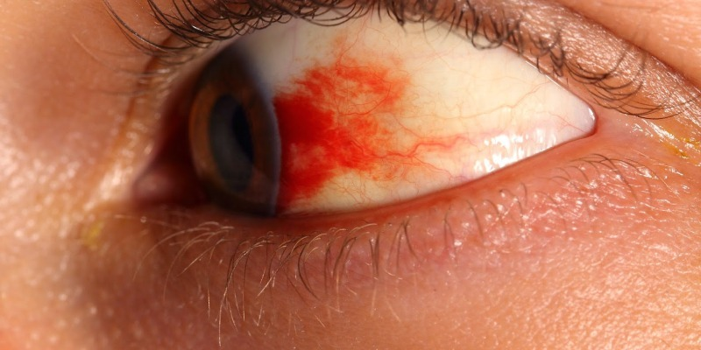

**Figure 1: Diabetic Retinopathy**

There are two main types of diabetic retinopathy:

1.Non-proliferative diabetic retinopathy (NPDR): In the early stage, small blood vessels in the retina may leak fluid, leading to swelling or edema. This can cause changes in vision.

2.Proliferative diabetic retinopathy (PDR): In the advanced stage, new blood vessels grow on the surface of the retina. These new vessels are fragile and can bleed into the vitreous, the gel-like substance that fills the center of the eye. This bleeding can lead to severe vision problems and even blindness.

Diabetic retinopathy often develops without any noticeable symptoms in the initial stages, so regular eye examinations are crucial for individuals with diabetes. Controlling blood sugar levels, blood pressure, and cholesterol can help prevent or slow the progression of diabetic retinopathy. Treatments may include laser surgery or other procedures to manage the condition, depending on its severity. It is essential for individuals with diabetes to work closely with their healthcare team to monitor and manage their overall health, including eye health.

**Cataract**

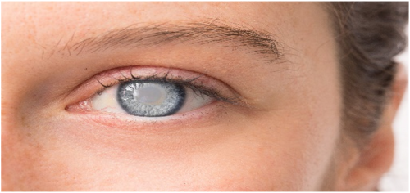

**Figure 2: Cataract**

Cataract is a disease that causes the eye to become cloudy or blurry. The sufferers of cataracts suffer severe vision loss, leading to various inconveniences in regular life such as driving, reading, cooking etc. This becomes much more severe during the night. Some cataracts become so severe that recognizing close objects and people becomes difficult. Cataracts develop slowly and are most of the time diagnosed at a late stage. The key to diagnosing and treating cataracts before they progress and affect quality of life is early identification. These are several symptoms that might be a sign of cataracts or another eye illness or condition.

**Glaucoma**

Glaucoma is a group of eye conditions that damage the optic nerve from an increased pressure within the eye. This can lead to vision loss, blurry vision and even blindness. Symptoms of glaucoma include peripheral vision loss, tunnel vision, eye-ache, nausea and blurred vision.

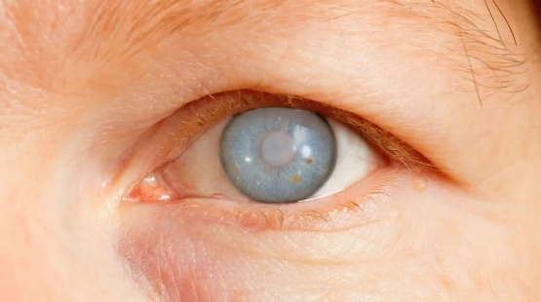

**Figure 3: Glaucoma**

The disease is treated via various methods depending on the type and severity. It can range from medications, laser therapy, surgery, and implantable devices. Lifestyle changes can also help the body resist glaucoma. Since the symptoms appear slowly over time, individuals often may not be aware of it until symptoms are serious, thus early detection is necessary for the best care.

## **1.2 Purpose and Goal of the Project**

The concern for this study is eye diseases such as diabetic retinopathy, glaucoma and cataract and to demonstrate how the proposed novel system detects diabetic retinopathy through Edge devices using a versatile and portable Tensor Flow Lite model, allowing for the development of Edge Intelligence applications, effectively describing this ML model as Edge Machine Learning or Edge Intelligence model.

The Edge device detection model when implemented through camera, can resolve the problem of the pupil of the eye getting too tiny that hinders detection of diabetic retinopathy. Healthcare experts may directly take a fundus image using diopter lens and use the proposed model via software to instantly detect presence of eye diseases. Other complex techniques to take fundus images will not be necessary, thus removing the problem of pupils getting too tiny due to direct light or risk of unreliable/inaccurate results.

Furthermore, the objective of this study was also to determine the most optimized model in terms of model size, execution time, stability, and memory consumption when used in software to ensure maximum compatibility of the Edge Intelligence model on Edge devices. For demonstration, this study implemented the ML model on smartphones via an Android app via TensorFlow Lite. The proposed model is called Optimized Light Weight Sequential Deep Learning Model or SDLM2, derived from a similar study conducted by the team concerning Cataracts. Likewise, this model can also be used to detect DR without internet connection. Doctors and Hospitals can then make use of this Deep Learning model to save costs and effort in detecting ocular diseases in patients.

## **1.3 Organization of the Report**

Chapter 2 contains the literature review relevant to our project and study. Chapter 3 outlines the methodology which contains the complete system model, architecture, dataset and implementation. Chapter 4 describes, analyzes, and compares the results of the study with other relevant research. Chapter 5 discusses the social, cultural, health, safety, and cultural impacts along with its impact and relevance to the environment and sustainability. Finally, the thesis and so the study is concluded with the complete summary of the project from its design, relevance and outcome to its limitations and future improvements.

# **Chapter 2 Literature Review**

## **2.1 Existing Research and Limitations**

The paper**, Automated detection of diabetic retinopathy using convolutional neural networks on a small dataset**, [1] published on **12th** **May** **2020**, by **Abishek** **Samanta** **et** **al**, proposes a Deep Learning model based on CNN transfer learning on DenseNet model, to detect 4 degrees of Diabetic Retinopathy. The model was trained on a total 3469 images as a dataset. The paper states that it faced a problem with uneven or skewed dataset composition which resulted in overfitting. DenseNet121 was selected after comparing results with models such as VGG16[18] and InceptionV3. The epoch of 50 was used and the image was preprocessed by increasing contrast and reducing black in the background to make the finer details visible more. Finally, the images were processed to a size of 360x360, and blur removed with Gaussian Filter. Moreover. The result of the training showed that epoch beyond 50 caused overfitting and showed high loss in learning. Nevertheless, their proposed model produced a good validation accuracy of 84.10%. Since the data had overfitting, the paper did not use this accuracy or F1 score as the main indicator of model performance, rather the paper used Cohen’s Kappa as the main comparable metric since it can neglect effect of overfitting. The F1 score of this paper is 0.64 on Mild DR and 0.74 on Moderate DR whereas, Kappa score is 0.8836 on validation and 0.9809 in training data. Although it concludes by stating the model has acceptable results, the paper does not compare with existing solutions in detail, nor does it state demonstration results. Thus, even with skewed dataset, the preprocessing technique allowed the training process to recognize the image details with great accuracy. Our model **SDLM2** trains on a more balanced dataset distribution and demonstrates the performance and compares with various metrics of the model with existing studies and models for suitable use in Edge Devices.

The paper, **An Approach to Detecting Diabetic Retinopathy based on Integrated Shallow Convolutional Neural Networks**,[2] published by **Wanghu Chen et al**, explores the use of shallow CNN with a novel performance integration, with a smaller number of layers to train a Diabetic Retinopathy detection model. The study uses a dataset of 35,126 labelled images where label denotes the level of DR. Preprocessing of the dataset were done by resizing to a size of 256x256 and were cleaned to express the details more by removing background, using Histogram Equalization, and Normalization. The dataset was then divided into 10 sub datasets of various size and randomly used to ensure different image features were included in training. Moreover, the model uses multiple shallow CNNs as base learners each has two convolutional layers, two pooling layers, and one fully connected layer. The number of base learners were added to observe increase of accuracy in results. Going above 5base learners of shallow CNNs do not increase accuracy anymore. This combination of base learners shows positive results as accuracy is greater than the single best base learner. Moreover, increasing dataset size also shows an increase in accuracy metrics. The integration approaches used were also compared which showed that Mean based integration had an accuracy of 0.83, Voting based had 0.82, while the proposed Performance based Integration had an accuracy of 0.86. The complete proposed model was also compared with CNN architecture derivations both on original dataset and sub-dataset which showed acceptable results given that the proposed model is a shallow CNN model with minimum number of layers. Specifically, the proposed approach shows a 9% and 3% higher accuracy than VG16noFc and LCNN on original dataset, 3% higher than ConvNet on the 1000 image dataset. Lastly, the complete integrated model which is trained on only 10% dataset size of the original shows only a 3% lower accuracy than LCNN. Thus, the study confidently concludes that the proposed model combined with the proposed performance integration, is effective in training DR dataset with both repeated and lack of high-quality labelled data. Although the study also states that this technique ensures high efficiency in training and classification, no such demonstration was given. Lastly, the deployment of the model was also not stated. Our proposed SDLM2, even though has a deeper CNN structure and smaller dataset size, it has optimum performance to deliver rapid results instantly when used via software.

The paper, **Mobile detection of cataracts with an optimised lightweight deep Edge Intelligent technique,** [3]published on, **January 1st, 2024**, by **Dipta Neogi et al**, proposes a CNN model which differentiates between healthy eyes and eyes with Cataracts. The focus of the study was on creating a lightweight Deep Learning model which can be used on any Edge devices ranging from modern hardware such as smartphones to low-powered hardware. This was achieved by balancing the number of trainable parameters and CNN layers, so that the deployed model has a rapid execution time, in this case [enter time], and size of [enter size], when converted to a Tensorflow Lite model. Tflite support ensures it is highly compatible and portable. A dataset of 1000 images was used to train the proposed **SDLM** model, which achieved an accuracy of 93%. Optimizer performances were compared between Adam Adadelta, and SGD, where Adam was chosen due to its better output in small dataset. Moreover, the proposed model does not require network connection and can work natively. Our model of this thesis follows similar methodology to this paper but is looking to expand on the study by adding classification capabilities of Diabetic Retinopathy as well. The paper’s lack of a larger dataset, which affected the study’s results, may be overcome.

The publication “**Detection of cataract based on image features using convolutional neural networks**,” [4] published on **January 2021**, works with a deep learning CNN model to increase accuracy and minimize data loss, and hence to find an optimal CNN model with the epoch number, which can accurately detect cataract on eyes. Achieved by increasing epochs to raise accuracy values and reduce data loss in cataract detection. Using a V3 architecture produced 87.5% accuracy with transfer learning and TensorFlow. DCNN was used to extract image features. Increasing the dataset content increased the DCNN accuracy for image feature extraction and classification. Adam optimizer was used with an exponential rate of decline of 0.9 and 0.999, epsilon = 10−8, and along with the CNN layers, a Dropout regulation was used to strengthen the training model further. The dataset was based on Fundus imaging with a size of 150 × 150 and later augmented to increase the sample size. The study was concerned with the value of accuracy and its changes with increasing epochs. The training results showed that increasing the epoch to 50 gives an accuracy of 97% with a 0.05% error. The model is tested against 10 new images, and an average accuracy of 88% is observed. The aim of this study was to use CNN classification and deep learning techniques to reduce data loss and improve the accuracy rate of cataract detection. In the paper, deployment or implementation of the suggested approach was not mentioned. The proposed SDLM2 algorithm accuracy (90%) is higher than the average accuracy (88%) of this model.

In the paper, “**Cataract detection based on ocular B-ultrasound images by collaborative monitoring deep learning**,” [5] published on **30 August 2021**, a collection of ocular B-ultrasound images is compiled and used on a customized Deep Learning technique called ‘Collaborative Monitoring Deep Learning’ (CMDL) approach to identify cataract, based on YOLO-ve objection detection network. This research worked on a scarce ultrasound imaging dataset which contains high noise. Hence, three types of feature extraction techniques had to be used based on DenseNet-161: a depth feature extraction module, a shape feature extraction module, and a texture feature extraction module. Extracted features from eyeballs and lenses are fused to detect whether they belong to the same category and then move forward to detect cataracts. This CMDL technique uses Fourier Descriptors to identify shape features, Grey-Level- Co-Occurrence Matric to identify Texture Features and DCNN for Deep Features. This also negates the overfitting problem of working with a small dataset. The result derived from the paper's proposed method with all the modules included yields an accuracy of 98.01%, while removing and adding the different modules yielded much lower accuracy. As the main purpose of this research was the detection of cataract more precisely with B-ultrasound images of cataracts, proper implementation of this algorithm on different platforms was not stated. Extraction of features on these images and CMDL approach make this algorithm more complex which requires more space and execution time than the proposed SDLM2.

In the study “**A robust automated cataract detection algorithm using diagnostic opinion-based parameter thresholding for telemedicine application**,” [6] published in September 2016, a system to automatically identify cataracts in adult humans using color photographs is proposed and evaluated. The topic of concern of this study is to develop a system that can consistently detect cataract on any device capable of using images as input and showing output. The paper uses a method based on texture feature extraction. It uses its uniformity, intensity, and standard deviation parameters to generate a histogram to predict the presence of cataracts, which ophthalmologists can use to screen for cataracts in patients. Initially, the image is preprocessed via smoothing and denoising by converting the image to greyscale and applying a Gaussian Filter. The result shows that a uniformly distributed histogram for intensity stands for healthy, clear eyes. Uniformity, intensity, and standard deviation are given thresholds to indicate different levels of cataracts. For cataract eyes, the histogram shows high-intensity values, high standard deviation, and a non-uniform histogram distribution. After evaluating the model on patients, with consistent and reliable results, it was combined with a user interface for websites and mobile apps and allowed to be used via the Internet. The result will be analyzed, calculated from a server, and sent to a doctor for conclusion. The application of the suggested system, MATLAB, was used to construct a Graphic User Interface (GUI), which needs server access to analyze and diagnose cataracts. This method turns the system into an internet-based one. But the proposed SDLM2 can work without having any Internet connection. Although there are possibilities of applying this interface on different platforms like websites, mobile application and others but none were shown.

The paper “**The use of convolutional neural network and digital camera images in cataract detection**,” [7] published on **March 2022**, proposed a CNN with digital camera images (CNNDCI) system to detect cataracts efficiently and effectively. The system can perform the cataract identification process accurately in a user-friendly manner using smartphones to collect digital images. Numerical results revealed that the system could identify cataracts effectively with satisfying accuracy. This study concluded that the presented CNNDCI architecture is a feasible and promising alternative for cataract detection. This study used digital camera images to train a convolutional neural network classifier to detect cataracts. Although, this paper's solution required an Internet connection as the image had to be sent to a server. This paper does not mention whether the system can be implemented on other Edge devices or not. Again, it is not stated, what will be the consequences of server failure or lack of Internet issue. Whereas the proposed SDLM2 works on Edge devices without any Internet connection.

The paper, “**CataractNet: An automated cataract detection system using deep learning for fundus images**,” [8] published in **September 2021**, uses a novel deep neural network, CataractNet, for automatic cataract detection in fundus images. The loss and activation functions are tuned to train the network with small kernels, fewer training parameters, and layers. Experimental results show that the proposed method outperforms the state-of-the-art approaches with an average accuracy of 99.13%. This paper's lightweight model automates the most popular screening technique. However, their system's target audience is professionals, not the public, since it does not mention how it can be used or what device it supports. Furthermore, their paper mentions a lack of available data, and augmentation had to be used. This paper uses Fundus images for the detection of cataract, but the proposed SDLM2 uses live images of eye for the detection of cataract which gives advantage of being supported by more types of devices.

The paper “**Diabetic retinopathy detection using machine learning and texture features**,” [9] published on **August 2018**, proposes the use of texture features extracted from the retinal fundus images to extract HEM and detect DR. For experimental validation, 1200 color images were acquired by three ophthalmologic departments using a 3 CCD camera on a Topcon TRCNW6 non-mydriatic retinography with a 45° field of view. Medical experts diagnosed each image and evaluated the presence of DR and a retinopathy grade. The color images are converted to grayscale for further processing. Learned HEM indicators and DR/non-DR distinctions are made using features retrieved from retinal fundus images. The kernels that detected DR the best was polynomial and RBF. According to experimental tests with the MESSIDOR database, LESH and LTP function well in detecting DR. However, Fundus pictures and medical professionals are still needed. This paper suggests a histogram binning scheme representation which is classified by support vector machine (SVM). The deployment of this system on any kind of platform was not mentioned clearly. The proposed SDLM2 uses CNN while this research uses SVM for classification.

The paper “**Comparison of machine learning and traditional classifiers in glaucoma diagnosis**,” [10] published on 9 September 2002, discussed the results of a study comparing the effectiveness of several machine learning algorithms in glaucoma diagnosis using the results of visual field sensitivity test. The study discovered that machine learning techniques outperformed conventional diagnostic indices, including multilayer perceptron and SVMs. The classification rate was increased, and the testing duration was decreased by employing forward-selection and backward-elimination techniques. The research indicates that glaucoma diagnosis may benefit from machine learning techniques. Deployment platform of this entire system was not mentioned. Moreover, the study works with optic disc photograph while SDLM works with live eye images. Thus, SDLM2 when deployed on Edge devices can be used by anyone to detect eye diseases such as DR, Cataracts, and Glaucoma, while the proposed model of this paper is to aid physicians in their tests of determining Glaucoma.

The paper “**Dual machine-learning system to aid glaucoma diagnosis using disc and cup feature extraction**,” [11] published on **10 July 2020**, explains the development of a diagnostic tool to detect glaucoma. Using eye fundus images, which combines two independently trained and tested subsystems. The first subsystem uses machine learning and segmentation techniques to detect the optic disc and cup and extract their physical and positional features. The second subsystem applies transfer learning techniques to a pre-trained CNN to detect glaucoma by analyzing the complete eye fundus images. The results of both subsystems are combined to discriminate positive cases of glaucoma and improve final detection, with higher classification rates than previous works. The tool also provides information to help ophthalmologists make diagnosis suggestions. Glaucoma is a degenerative disease that affects vision, causing damage to the optic nerve and resulting in vision loss. The model is said to be deployed in an embedded system, but specific requirements are not mentioned.

The paper, “**Adaptive feature squeeze network for nuclear cataract classification in AS-OCT imag**e,” [12] published on **March** **2022**, introduces a new method for automatically classifying the severity levels of nuclear cataract (NC), an age-related cataract disease using anterior segment optical coherence tomography (AS-OCT) images. Cataract surgery is an effective treatment for NC patients, and AS-OCT images provide non-invasive and clear visibility of opacity in the lens nucleus region. However, previous research on automatic AS-OCT-based NC classification is limited. The proposed method in this paper is called Adaptive Feature Squeeze Network (AFSNet), which utilises a CNN framework. AFSNet incorporates an adaptive feature squeeze module that dynamically compresses local feature representations and updates the importance of global feature representations. This module consists of a squeeze block and a global adaptive pooling operation. To evaluate the effectiveness of AFSNet, the researchers conducted comprehensive experiments on both a clinical AS-OCT image dataset and a public OCT images dataset. The results demonstrate that AFSNet outperforms strong baselines and previous state-of-the-art methods, indicating its superiority in NC severity classification. Additionally, the study reveals that CNNs perform better in classifying NC in the nucleus region compared to the lens region. Furthermore, the paper uses the class activation mapping (CAM) technique to identify the discriminative regions the CNN models learn. This technique enhances the interpretability of the classification results by localizing the regions that contribute most to the classification. In conclusion, this paper presents the AFSNet framework for automatic NC severity classification using AS-OCT images. The experiments validate the effectiveness of the proposed method and highlight its superiority over existing approaches. Including CAM enhances the interpretation of the classification results by identifying the significant regions in the images. This model is trained on detecting cataract from AS-OCT images, which requires specialized devices; however, SDLM2, as demonstrated on the I-Scan app, can deploy on any Edge device to detect cataract from live eye photos that can be taken from the device camera itself with the use of a proper diopter lens. The paper does not specify a specific platform of deployment.

The paper “**Automatic cataract classification based on ultrasound technique using machine learning: A comparative study**,” [13] published in **2015**, addresses using an ultrasound-based computer-aided diagnostic (CAD) system to categorize cataracts. The study created B-mode and Nakagami pictures using ultrasonic A-scan signals from 220 porcine lenses. Acoustic, spectral, and picture textural investigations yielded 97 parameters; Principal Component Analysis (PCA) was then used to choose the features. Fisher Linear Discriminant, Bayes, K Nearest Neighbours, and SVM, four classifiers that were examined, performed well at categorizing healthy and cataractous lenses. Over 10% of the working population is affected by age-related cataracts, which account for 48% of blindness cases globally. The surgical process known as phacoemulsification is frequently used to restore eyesight, but maintaining the integrity of the lens capsule is essential to prevent complications and visual loss. Establishing the ideal phacoemulsification energy level is crucial which depends on the lens hardness. For clinical prognosis and treatment, objective diagnosis of cataract type and severity, particularly in the initial stages, is crucial. It has been proven that ultrasound techniques may accurately describe the hardness of cataracts. To automatically categorize cataracts, this study used acoustic characteristics and backscattering signals from porcine lenses with various levels of cataract. This strategy aims to extract information from the acoustic parameters and backscattering signals for machine learning-based categorization, as opposed to subjective methods that rely on retro illumination and slit-lamp images. The research suggests a methodology for classifying cataract from ultrasound pictures that can be used by CAD systems. As a result, it can be used with medical equipment and tools to facilitate classification. In contrast, the proposed model SDLM2 uses live images that can be taken from a smartphone camera, as demonstrated in the I-Scan app. This allows for offline recognition of the image and instantaneous results and not specific to any medical tools and machines.

The publication, “**Glaucoma detection in retinal fundus images using U-Net and supervised machine learning algorithms**,”[14] published on **July** **2021**, proposes a fundus image-based offline CAD system that integrates image processing, deep learning, and machine learning methods. The system uses the brightest spot approach to detect regions of interest (ROIs), while the Le-Net architecture is used to evaluate input photos. The U-Net architecture is used to segment the optic disc and optic cup. With the help of SVM, Neural Networks, and Adaboost classifiers, classification tasks are completed. The outcomes show remarkable accuracy at various systemic phases. Le-Net validates input images with an accuracy of 99%, while the brightest spot algorithm extracts ROIs with an accuracy of 98.67%. The dice coefficients obtained from segmenting the optic disc and cup using U-Net architecture are 0.93 and 0.87, respectively. Using SVM, Neural Networks, and Adaboost classifiers, classification accuracy, recall, specificity, and sensitivity exceed 100%. In conclusion, the suggested desktop application is simple to use and important for glaucoma early identification. The CAD system's modular construction enables the use of individual components for various glaucoma detection and classification tasks. The system's accuracy and robustness are due to training on various datasets. To identify glaucoma from retinal fundus images, a model for an offline CAD system is proposed here. To make cataract detection low-cost and portable—like using a smartphone, as the I-Scan app demonstrates—the proposed model SDLM2 focuses on distributing the model on Edge Devices, not only CAD system.

The paper “**Cataract disease detection by using transfer learning-based intelligent methods**,” [15] published in **December** **2021**, focuses on classifying cataract disease using CNNs based on a publicly available image dataset. Cataracts are a common visual disorder that occurs as people age, causing a clouding of the lens in the eyes. Symptoms include blurred vision, faded colors, and difficulty seeing in bright light, which can hinder daily tasks and potentially lead to blindness. The study utilizes four CNN meta-architectures, namely InceptionV3, InceptionResnetV2, Xception, and DenseNet121, implemented through the TensorFlow object detection framework. Among these architectures, InceptionResnetV2 achieved the best results in detecting cataract disease. The model achieved a training loss of 1.09%, a training accuracy of 99.54%, a validation loss of 6.22%, and a validation accuracy of 98.17% on the dataset. It also demonstrated a sensitivity of 96.55% and a specificity of 100%. Furthermore, the model successfully reduced training loss while improving accuracy, indicating its effectiveness in classifying cataract disease. This research employs CNNs to classify cataract disease using a publicly available image dataset. The InceptionResnetV2 architecture performed exceptionally well, demonstrating high accuracy and minimising training loss. These findings have implications for the early detection and prevention of cataracts to reduce the incidence of blindness. The study simply discusses the performance and comparability of the various models that were implemented; it makes no mention of the model's deployment location. Although the authors note at the end of the paper that it can be deployed on a website to be available globally, since TensorFlow was used it can be deployed on any device that supports TensorFlow Lite. However, the suggested model SDLM2 is most appropriate for deployment on Edge devices, due to its small weight and low computational requirement.

# **Chapter 3 Methodology**

## **3.1 System Design**

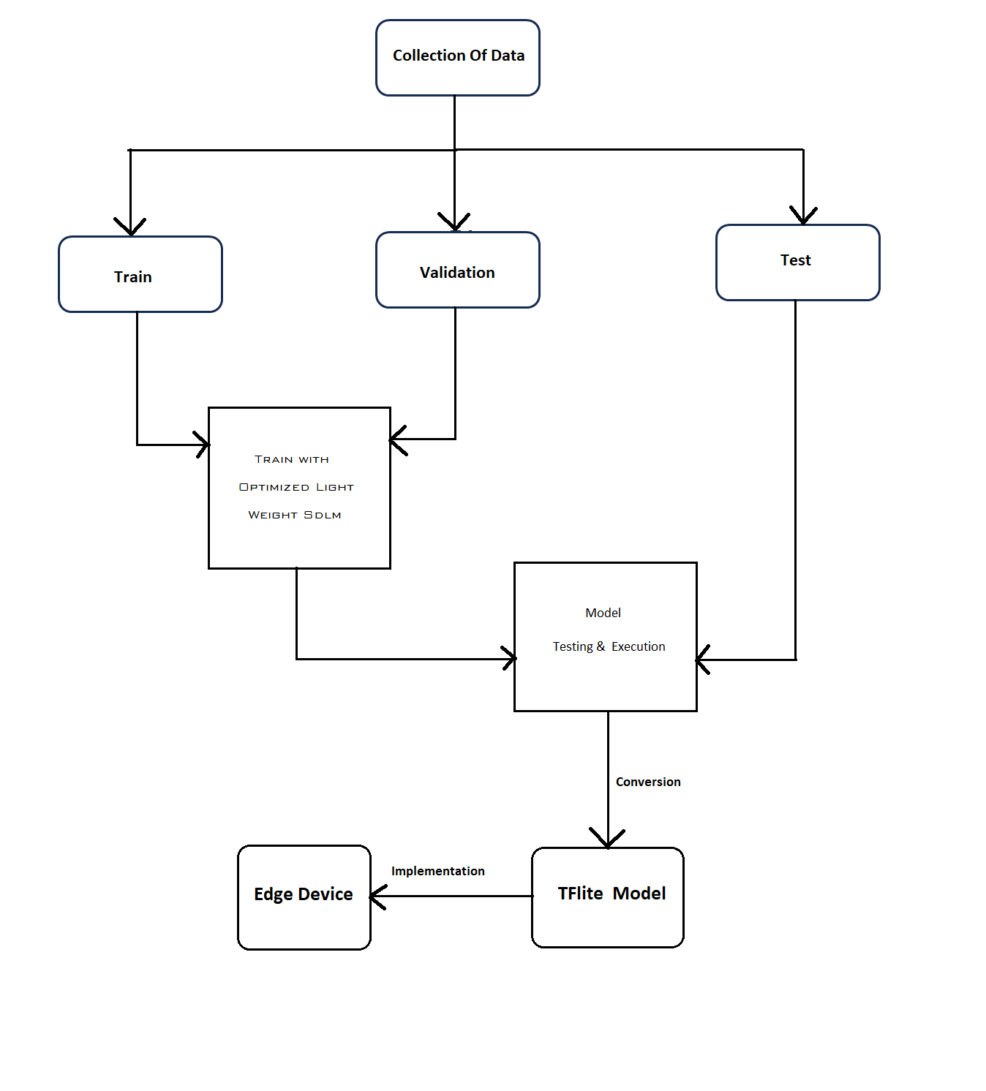

**Figure 4: System Design Flowchart**

**3.1.1 CNN Model**

The CNN model employed for the classification of ocular conditions follows a meticulously crafted architecture tailored for discerning images of cataracts, Diabetic Retinopathy, glaucoma, and healthy eyes. This model traverses a series of carefully constructed layers and filters, each designed to extract and emphasize relevant features crucial for accurate classification. At its core, the CNN model leverages convolutional layers to systematically scan and analyze the intricate details present within each image. These convolutional layers are adept at detecting patterns and nuances that signify specific ocular conditions, facilitating precise classification.

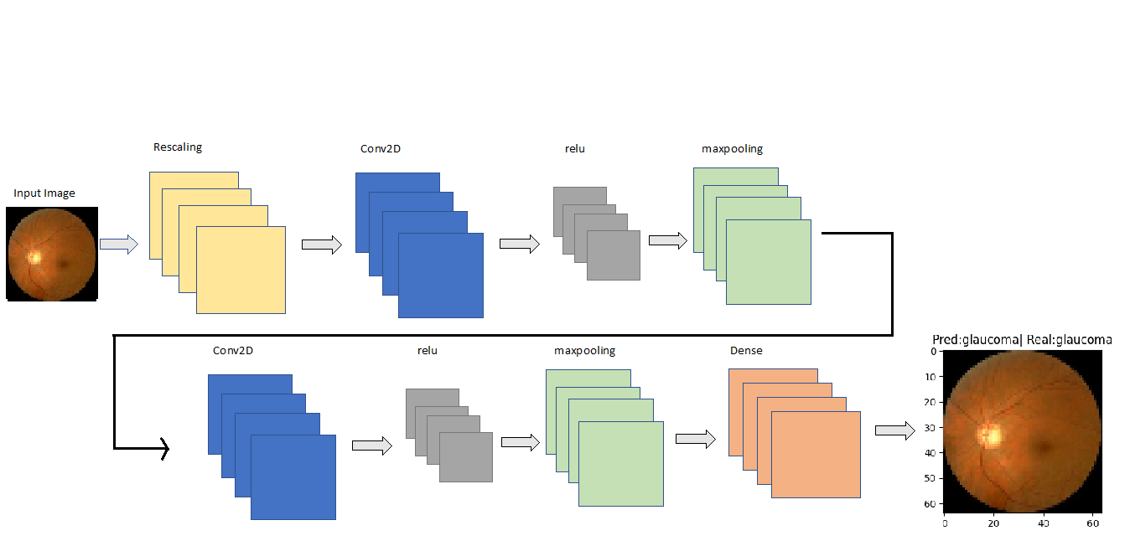

**Figure 5: Proposed CNN Model**

**3.1.2 Model Architecture**

The defined model architecture, SDLM2, comprises a Sequential model constructed using TensorFlow's Keras API. It begins with a Rescaling layer to normalize pixel values between 0 and 1. Following this, a series of Conv2D layers is employed to extract hierarchical features from the input images, gradually increasing the number of filters to capture more complex patterns. Each Conv2D layer is accompanied by a MaxPooling2D layer, which reduces spatial dimensions while retaining essential features. The use of "same" padding ensures that the spatial dimensions remain consistent throughout the convolutional layers. After several rounds of convolution and pooling, the resulting feature maps are flattened and fed into densely connected layers for classification. Specifically, there are two Dense layers with ReLU activation functions, followed by a Dropout layer to mitigate overfitting. Finally, the output layer consists of four neurons, representing the classes to be predicted: cataracts, Diabetic Retinopathy, glaucoma, and healthy eyes, without any activation function, indicative of a raw output used for classification.

In the model compilation phase, the dynamic "Adam" optimization algorithm takes the lead, dynamically adjusting the learning rate as it progresses through the training process. Renowned for its adaptive nature, Adam seamlessly blends the advantages of momentum gradient descent with the precision of Root Mean Square Propagation (RMSP), offering unparalleled adaptability and convergence speed. To discern the optimal algorithm, our results are meticulously juxtaposed with those derived from Stochastic Gradient Descent (SGD) and Adadelta. This rigorous comparison aims to unveil the algorithm that best complements our model's intricacies and dataset characteristics, ensuring that our approach is not only robust but also finely attuned to the nuances of ocular health classification.

### **3.1.3 CNN Layer Configuration**

|  |  |  |  |
| --- | --- | --- | --- |
| **Layer** | **Type** | **Filter Configuration** | **Output Shape** |
| 1 | Rescaling | N/A | (20, 64, 64, 3) |
| 2 | Conv2D | 32 filters,4x4 | (20, 61, 61, 32) |
| 3 | Maxpooling2D | N/A | (20, 30, 30, 32) |
| 4 | Conv2D | 64 filters,3x3 | (20, 30, 30, 64) |
| 5 | Maxpooling2D | N/A | (20,15,15,64) |
| 6 | Conv2D | 128 filters,3x3 | (20,15,15,128) |
| 7 | Maxpooling2D | N/A | (20,7,7,128) |
| 8 | Conv2D | 256 filters,3x3 | (20,7,7,256) |
| 9 | Maxpooling2D | N/A | (20,3,3,256) |
| 10 | Flatten | N/A | (20,2304) |
| 11 | Dense | 512 units | (20,512) |
| 12 | Dropout | N/A | (20,512) |
| 13 | Dense | 128 units | (20,128) |
| 14 | Dense | 4 units(output) | (20,4) |

**Table 1: CNN Layer Configuration**

1. Rescaling Layer: This layer rescales the input pixel values by dividing them by 255, which standardizes the pixel values between 0 and 1. The output shape is (20, 64, 64, 3), indicating a batch of 20 samples with an input image size of 64 x 64 and 3 color channels (RGB).

2. Conv2D Layer (1st Convolutional Layer): This layer applies 32 filters of size 4x4 to the input images using the ReLU activation function. It performs a convolution operation on the input, resulting in an output feature map with a shape of (20, 61, 61, 32) after applying the filters and preserving the spatial dimensions.

3. MaxPooling2D Layer (1st MaxPooling Layer): This layer performs max pooling on the input feature maps, reducing their spatial dimensions by a factor of 2 along both the height and width dimensions. The output shape is (20, 30, 30, 32), indicating a reduction in spatial resolution.

4. Conv2D Layer (2nd Convolutional Layer): This layer applies 64 filters of size 3x3 to the input feature maps with padding set to "same", preserving the spatial dimensions of the input. The output feature map has a shape of (20, 30, 30, 64).

5. MaxPooling2D Layer (2nd MaxPooling Layer): This layer performs max pooling on the input feature maps, reducing their spatial dimensions by a factor of 2 along both the height and width dimensions. The output shape is (20, 15, 15, 64), indicating a further reduction in spatial resolution.

6. Conv2D Layer (3rd Convolutional Layer): This layer applies 128 filters of size 3x3 to the input feature maps with padding set to "same", preserving the spatial dimensions of the input. The output feature map has a shape of (20, 15, 15, 128).

7. MaxPooling2D Layer (3rd MaxPooling Layer): This layer performs max pooling on the input feature maps, reducing their spatial dimensions by a factor of 2 along both the height and width dimensions. The output shape is (20, 7, 7, 128), indicating a further reduction in spatial resolution.

8. Conv2D Layer (4th Convolutional Layer): This layer applies 256 filters of size 3x3 to the input feature maps with padding set to "same", preserving the spatial dimensions of the input. The output feature map has a shape of (20, 7, 7, 256).

9. MaxPooling2D Layer (4th MaxPooling Layer): This layer performs max pooling on the input feature maps, reducing their spatial dimensions by a factor of 2 along both the height and width dimensions. The output shape is (20, 3, 3, 256), indicating a further reduction in spatial resolution.

10. Flatten Layer: This layer flattens the input feature maps into a one-dimensional array, preparing them for input into the subsequent fully connected layers. The output shape is (20, 2304), representing a flattened array of length 2304 for each sample in the batch.

11. Dense Layer (1st Dense Layer): This layer consists of 512 units with the ReLU activation function. It performs a fully connected operation on the flattened input, transforming it into a new feature representation. The output shape is (20, 512).

12. Dropout Layer: This layer applies dropout regularization, randomly setting a fraction of input units to 0 during training to prevent overfitting. It does not alter the shape of the input.

13. Dense Layer (2nd Dense Layer): This layer consists of 128 units with the ReLU activation function. It further transforms the feature representation obtained from the previous dense layer. The output shape is (20, 128).

14. Dense Layer (Output Layer): This layer consists of 4 units, representing the number of classes in the classification task. It outputs raw predictions for each class, and it does not apply any activation function. The output shape is (20, 4).

## **3.2 Hardware and/or Software Components**

### **3.2.1 Machine learning Model**

The proposed approach to detect cataracts, diabetic retinopathy, glaucoma will be made through the CNN model and Android base conversion of that trained model. This process includes major steps, including creating a new CNN model, converting the model for the Android system, taking images from the Android system and detecting images as healthy or not. This proposed structure is described in the Flowchart given above.

### **3.2.2 Dataset**

|  |  |  |  |
| --- | --- | --- | --- |
| **Classes** | **Train** | **Test** | **Validation** |
| Cataract | 726 | 209 | 103 |
| Diabetic retinopathy | 768 | 221 | 109 |
| Glaucoma | 704 | 203 | 100 |
| Normal | 751 | 216 | 107 |
| total | 2949 | 849 | 419 |
| percentage | 70% | 20% | 10% |

|  |  |  |  |  |
| --- | --- | --- | --- | --- |
| **Classes** | **Train** | **Test** | **Validation** | **Total** |
| No DR | 18067 | 5162 | 2581 | 25810 |
| Mild | 1710 | 489 | 244 | 2443 |
| Moderate | 3704 | 1059 | 529 | 5292 |
| Severe | 611 | 175 | 87 | 873 |
| Proliferative DR | 495 | 143 | 70 | 708 |
| Total | 24589 | 7024 | 3513 | 35126 |

**Table 2: Dataset 1 -Complete Distribution of all Diseases**

**Table 3: Dataset-2 (Distribution of Diabetic Retinopathy)**

Two datasets were used, one with 4 distinctive classes for 4 diseases: Cataracts, Diabetic Retinopathy, Glaucoma, and Normal, totaling 4217 images and divided in the same folders of train, validation and test. Each folder is divided into four categories: Normal, Diabetic Retinopathy, Glaucoma, and Cataract. The ratio is also kept the same as with the first dataset of 70:20:10.

The training folder contains 726 images for Cataracts, 768 for DR, 704 for Glaucoma, and 751 for healthy eyes. The images were preprocessed to 64x64 pixels to maintain consistency.

Our second data set had only Diabetic Retinopathy of 5 classes, spanning from the absence of the condition to its most severe. With a collection of 35,126 images at our disposal, we partitioned the dataset into training, testing, and validation sets, adhering to a ratio of 70:20:10. This yielded a model accuracy of 73.43%. Following this success, we proceeded to refine our approach with a more focused iteration, with a subset of 3,246 images.

### **3.2.3 List of Software / Hardware Tools Used**

|  |  |  |  |
| --- | --- | --- | --- |
| **Tool** | **Function** | **Other Similar Tools (if any)** | **Why Selected This Tool** |
| Google Colab | Model coding and training environment | Kaggle, Jupyter | Allows to collaborate with members over the internet and use hardware resources from the cloud. |
| Python | Language used for Machine Learning model training and creation | N/A | Extensive libraries for graphing, machine learning, modelling, code is easier to write saving time and effort. |
| Tensorflow | Library used to create the ML model | Pytorch | Contains structures, and functions to perform image processing, image recognition and create models. |
| Android Studio | IDE to code for Android app | VSCode | Android app development is simpler for demo can be simulated. |
| Smartphone | Take photos | PC, Edge Devices | To demo the app using phone camera. |

**Table 4: List of Software/ Hardware Tools Used**

## **3.3 Hardware and/or Software Implementation**

An Android App named I-Scan was created to demonstrate and implement the Edge Intelligence SDLM2. It allows an Edge device or, in this case, a smartphone application to use machine learning techniques and incorporate the model into one system to present an extremely easy solution to detect diabetic retinopathy SDLM2, stored locally in I-Scan, will use advanced datasets and algorithms based on data structures and advanced neural networks to detect diabetic retinopathy from any image provided by the camera module of the Android system. The key features of I-Scan are:

* Detecting the presence of diabetic retinopathy based on the image provided to the customized model.
* Selecting photos from internal storage to detect diabetic retinopathy. No requirement for the Internet to scan images or produce results.
* Light-weight app that can run on almost any Android device.
* Featuring a simple and basic UI that anyone with a smartphone can operate.
* No good knowledge of Android app usage is necessary.

I-Scan will be a powerful yet simple tool to detect diabetic retinopathy without seeking help from trained professionals and remove the troubles of going through long wait times and using devices needed to produce special forms of images for testing one's eyesight. A perfect choice for people without access to medical facilities due to several factors. The only facility required is a smartphone. Similarly, customized software or applications can be created for specific Edge devices.

# **Chapter 4 Investigation/Experiment, Result, Analysis, and Discussion**

|  |  |  |  |  |  |  |
| --- | --- | --- | --- | --- | --- | --- |
| **Model** | **TFlite size** | **Average Execution Time** | **Trainable Parameters** | **Total Parameters** | **Total Layers + Depth** | **Accuracy** |
| Optimized CNN (SDLM2) | 6.24M | 70.16 s | 1635428 | 1635428 | 13 | 90.17% |
| ResNet-50  [17] | 93.62M | 78.43s | 1049220 | 24636932 | 181 | 57.36% |
| InceptionV3  [19] | 87.11M | 79.27 | 1051140 | 22853924 | 55 | 77.74% |
| MobileNetV2 | 10.96M | 37.22s | 657924 | 2915908 | 158 | 83.86% |
| DenseNet121 | 28.85M | 53.8s | 590980 | 7628484 | 432 | 77.74% |

**Table 5: Comparison of proposed model with other pre-trained models**

The table presents a comprehensive comparison between the optimized CNN model (SDLM2) and several other pre-trained models, namely ResNet-50, InceptionV3, MobileNetV2, and DenseNet121, across various metrics. Each model is evaluated based on its TensorFlow Lite (TFlite) size, average execution time, and the number of trainable parameters. Additionally, the table provides insights into the total parameters, total layers, depth, and accuracy of each model.

The study’s proposed model, SDLM2 model, with a TFlite size of 6.24M, exhibits an average execution time of 70.16 seconds and boasts 1,635,428 trainable parameters. It achieves an impressive accuracy of 90.17% with a total of 13 layers. Comparatively, ResNet-50, with a significantly larger TFlite size of 93.62M, registers an execution time of 78.43 seconds. It contains 24,636,932 total parameters, distributed across 181 layers, and achieves an accuracy of 57.36%. InceptionV3 and MobileNetV2 also exhibit substantial TFlite sizes of 87.11M and 10.96M, respectively. InceptionV3 shows an execution time of 79.27 seconds, 22,853,924 total parameters, and 55 layers, with an accuracy of 77.74%. Meanwhile, MobileNetV2 boasts a shorter execution time of 37.22 seconds, fewer total parameters (2,915,908), and 158 layers, achieving an impressive accuracy of 83.86%. Lastly, DenseNet121 presents a TFlite size of 28.85M, an execution time of 53.8 seconds, and 590,980 trainable parameters. With a total parameter count of 7,628,484, distributed across 432 layers, it attains an accuracy level matching that of InceptionV3 at 77.74%.

|  |  |  |  |  |
| --- | --- | --- | --- | --- |
| **Related Research**  **(Author)** | **Applied Methods** | **Minimum Total Layers** | **Dataset Size** | **Accuracy / %** |
| Abishek Samanta et al[1] | Transfer Learning with DenseNet121 | 121 | 3050 | 84.10 |
| Wanghu Chen et al  [2] | Shallow CNN | 5 | 35126 | 86.0 |
| Sehrish Qummar et al | Ensemble of Resnet50[17], InceptionV3, Xception, DenseNet121  [16], DenseNet169 | 5 | 35126 | 80.80 |
| Victor Vives-Boix, Daniel Ruiz-Fernandez | InceptionV3 | 48 | 3662 | 95.56 |
| Borys Tymchenko, Philip Marchenko et al | Image-net | 9 | 35126 | 99.30 |
| Dolly Das, Saroj Kumar Biswas et al | DRFEC | 20 | 35126 | 98.8 (average) |
| Dipta Neogi, Mahirul et al[3] | SDLM | 13 | 1000 | 93.44 |
| Proposed Study | SDLM2 | 13 | 4217 | 90.20 |

**Table 6: Comparison with methods from related studies**

The Table compares model performance based on total layers needed, dataset size, and accuracy with different related research and the paper’s proposed model SDLM2. Abishek Samanta et al. leveraged Transfer Learning with DenseNet121, employing 121 total layers on a dataset of 3,050 images to achieve an accuracy of 84.10%. Wanghu Chen et al. utilized a Shallow CNN approach, comprising 5 total layers, on a larger dataset of 35,126 images, achieving an accuracy of 86%. Sehrish Qummar et al. adopted an Ensemble approach, combining ResNet50, InceptionV3, Xception, DenseNet121, and DenseNet169, each with 5 total layers, on the same dataset of 35,126 images, achieving an accuracy of 80.8%. Victor Vives-Boix and Daniel Ruiz-Fernandez focused on InceptionV3, employing 48 total layers on a smaller dataset of 3,662 images, achieving an impressive accuracy of 95.56%. Borys Tymchenko, Philip Marchenko et al. employed Image-net, utilizing 9 total layers on the dataset of 35,126 images, achieving remarkable accuracy of 99.3%. Dolly Das, Saroj Kumar Biswas et al. introduced DRFEC with 20 total layers on the same dataset of 35,126 images, achieving an average accuracy of 98.8%. Dipta Neogi, Mahirul et al. proposed SDLM with 13 total layers on a dataset of 4,217 images, attaining an accuracy of 90.17%.

Derived from SDLM, SDLM2 maintains the number of layers but uses three times the dataset size and yet achieves an accuracy of 90.2. Compared with other models, SDLM2 manages to keep a high accuracy but not as high to have possibility of overfitting, within a low number of layers and a smaller dataset. Suggesting that SDLM2 can be used reliably when dataset quantity is low.

# **Chapter 5 Impacts of the Project**

## **5.1 Impact of this Project on Societal Health, Safety, Legal, and Cultural Issues**

The practicality of developing an Edge Intelligence model to detect diabetic retinopathy or any disease is high. The model can be implemented to automate Edge devices or embedded systems that cater to interest groups ranging from low to middle to high-income people, doctors, hospitals, or medical technology. Moreover, cost-efficient and time-saving Edge solutions (as demonstrated via the I-Scan app) can also be implemented to provide easy, low-cost, and rapid diabetic retinopathy identifying services to the underprivileged. The lack of privilege can be due to financial conditions and a lack of facilities. Thus, health professionals can effectively use this model to detect the presence of Diabetic Retinopathy rapidly and cheaply, catering to people of all socio-economic conditions. Although, Diopter lenses are needed to take fundus images which is still expensive to purchase and is mostly used by eye specialist or optical researchers.

Smaller clinics and health facilities can make use of this to diagnose DR without needing expensive medical equipment and specialists, which is often a problem in remote areas. Therefore, healthcare service and quality of life can be significantly made better in communities without proper access to high-end healthcare facilities.

## **5.2 Impact of this Project on Environment and Sustainability**

Since this is research focuses on developing Deep Learning models to create portable android for efficient disease detection, it has minimum impact on the environment. Yet, the portable Deep Learning model has a highly beneficial environmental contribution and is highly sustainable. The model can be easily transferred to other devices and imported to a codebase in the form of Tensorflow Lite. It can be used on any Edge Devices, low-powered hardware, as well as Smartphones, even without the use of the internet. Hence, high electricity consumption from large medical equipment, greenhouse gas emissions from shipping of such equipment will be completely minimized.

# **Chapter 6 Conclusion**

## **6.1 Summary**

Ocular diseases such Diabetic Retinopathy, Glaucoma, and Cataracts are common in the population. While they are easily treatable, without early detection, the diseases can lead to permanent blindness and severe discomfort. Detection requires trained professionals, tools and instruments, and the awareness of the individual, financial conditions and medical facilities. The study's proposed Optimised Light Weight Sequential Deep Learning Model 2 or SDLM2, allows for Edge Devices such as a smartphone to smoothly integrate the model to be used in a smart healthcare software and perform instantaneous cataract detection, without the presence of medical costs, facilities or medical practitioners.

The Optimised Light Weight Sequential Deep Learning Model 2 has shown high accuracy in classification between the three diseases and healthy eyes classes as the epoch is increased without being overfed. Furthermore, the CNN and the Convolutional and Maxpooling layers used along with the Adam optimizer show reliable results as the model's high capability of classifying between classes is in line with other similar studies/works given using similar methods of Deep Learning. Lastly, the proposed SDLM2 model is also easily integrated into the Android app to demonstrate SDLM2's operation in an Edge device.

Other related studies also show slow execution time and high memory costs and requirements, which may result from the higher number of layers and parameters used. On the other hand, the proposed TensorFlow Lite SDLM's minimal layer usage, parameter usage and methods suggest that SDLM's size requirement is significantly lower, and execution time is also faster. This enables even low-powered devices to integrate SDLM for automation. Furthermore, platform independence allows it to be implemented on any Edge device via customized software that supports TensorFlow Lite.

Unlike other related work and studies, SDLM2 does not have to rely on the Internet, and network calls to work, which takes time and slows execution speed. The locally stored model will allow rapid execution, execution without a network connection, and minimal device memory consumption, suitable for use in Edge Devices or devices without network connection.

## **6.2 Limitations**

The study’s limitation stemmed from the lack of a larger dataset and images with variation of lighting and angles. Since creating a dataset from scratch by taking images of volunteers was not possible, a fully customized dataset was not possible, this would have shown better results in both the ML output and better results if used physically. Another limitation is the high cost of diopter lens which is required to take fundus images directly through cameras. Better and complex preprocessing could have been applied if dataset were made from scratch, which could enhance classification capabilities of the model.

## **6.3 Future Improvements**

The model could be improved further by using images of various conditions with a diopter lens behind a camera. This would give the model better precision and accuracy of detection. The lens would also allow us to test the model directly on people instead of testing with images. Moreover, the use-case of the model could be expanded by adding more eye diseases or other visually detectable diseases to turn the model into a multiple disease detecting program not just limited to vision.

# **References**

1. A. Samanta, A. Saha, S. C. Satapathy, S. L. Fernandes, and Y.-D. Zhang, “Automated detection of diabetic retinopathy using convolutional neural networks on a small dataset,” *Pattern Recognition Letters*, vol. 135, pp. 293–298, May 2020. doi:10.1016/j.patrec.2020.04.026
2. W. Chen, B. Yang, J. Li, and J. Wang, “An approach to detecting diabetic retinopathy based on integrated shallow convolutional neural networks,” *IEEE Access*, vol. 8, pp. 178552–178562, 2020. doi:10.1109/access.2020.3027794
3. D. Neogi, M. A. Chowdhury, Mst. M. Akter, and Md. I. Hossain, “Mobile detection of cataracts with an optimised lightweight deep edge intelligent technique,” *IET Cyber-Physical Systems: Theory &amp; Applications*, Jan. 2024. doi:10.1049/cps2.12083
4. Weni, I., et al.: Detection of cataract based on image features using convolutional neural networks. IJCCS (Indo. J. Comput. Cyber. Syst.). 15(1), 75 (2021). https://doi.org/10.22146/ijccs.61882
5. Wang, Y., et al.: Cataract detection based on ocular B-ultrasound images by collaborative monitoring deep learning. Knowl. Base Syst. 231, 107442 (2021).
6. Pathak, S., Kumar, B.: A robust automated cataract detection algorithm using diagnostic opinion based parameter thresholding for telemedicine application. Electronics. 5(4), 57 (2016). https://doi.org/10.3390/electronic
7. Lai, C.-J., et al.: The use of convolutional neural networks and digital camera images in cataract detection. Electronics. 11(6), 887 (2022). https://doi.org/10.3390/electronics11060887.
8. Junayed, M.S., et al.: CataractNet: an Automated Cataract Detection System using deep learning for fundus images. IEEE Access. 9, 128799–128808 (2021). https://doi.org/10.1109/access.2021.3112938
9. Chetoui, M., Akhloufi, M.A., Kardouchi, M.: Diabetic retinopathy detection using machine learning and texture features. 2018 IEEE Canadian Conference on Electrical & Computer Engineering (CCECE). (2018). https://doi.org/10.1109/ccece.2018.8447809
10. Chan, K., et al.: Comparison of machine learning and traditional classifiers in glaucoma diagnosis. IEEE (Inst. Electr. Electron. Eng.) Trans. Biomed. Eng. 49(9), 963–974 (2002). https://doi.org/10.1109/tbme.2002.802012
11. Civit-Masot, J., et al.: Dual machine-learning system to aid glaucoma diagnosis using disc and cup feature extraction. IEEE Access 8, 127519–127529 (2020). <https://doi.org/10.1109/access.2020.3008539>
12. Xiao, Z., et al.: Adaptive feature squeeze network for nuclear cataract classification in AS-Oct image. J. Biomed. Inf. 128, 104037 (2022). <https://doi.org/10.1016/j.jbi.2022.104037>
13. Caxinha, M., et al.: Automatic cataract classification based on ultrasound technique using machine learning: a comparative study. Phys. Procedia. 70, 1221–1224 (2015). https://doi.org/10.1016/j.phpro.2015.08.263
14. Shinde, R.: Glaucoma detection in retinal fundus images using U-Net and supervised machine learning algorithms. Intelligence-Based Med. 5, 100038 (2021). <https://doi.org/10.1016/j.ibmed.2021.100038>
15. Hasan, M.K., et al.: Cataract disease detection by using transfer learning-based intelligent methods. Comput. Math. Methods Med. 2021, 1–11 (2021). <https://doi.org/10.1155/2021/7666365>
16. Huang, G., et al.: Weinberger. Densely Connected Convolutional Networks.[Internet]. Cornell University; (2018) [cited 2023 Jul 11]. Available from: [1608.06993] Densely Connected Convolutional Networks (arxiv.org)
17. He, K., et al.: Deep residual learning for image recognition. 2016 IEEE Conference on Computer Vision and Pattern Recognition (CVPR). (2016). <https://doi.org/10.1109/cvpr.2016.90>
18. Simon, M., Rodner, E., and Denzler, J.: ImageNet Pre-trained Models with Batch Normalization. [Internet]. Cornell University; (2016) [cited 2023 Jul 11]. Available from: [1612.01452] ImageNet pre-trained models with batch normalization (arxiv.org)
19. Szegedy, C., et al.: Rethinking the inception architecture for computer vision. 2016 IEEE Conference on Computer Vision and Pattern Recognition (CVPR). (2016). <https://doi.org/10.1109/cvpr.2016.308>